x


SOFTWARE REQUIREMENT SPECIFICATION
Food Ordering System

– Hanoi, Jan 2026 –
Table of Contents
I. Record of Changes 3
II. Software Requirement Specification 4
1. Overall Requirements 4
1.1 Context Diagram 4
1.2 Main Business Processes 5
1.3 User Requirements 5
1.4 System Functionalities 7
1.5 Entity Relationship Diagram 7
2. Use Case Specifications 8
2.1 <<Feature Name1>> 8
2.2 Xyz Feature 10
3. Functional Requirements 11
3.1 Feature Name1 11
3.2 User Authentication 11
3.3 System Administration 12
4. Non-Functional Requirements 13
3.1 External Interfaces 13
3.2 Quality Attributes 13
5. Requirement Appendix 14
5.1 Business Rules 14
5.2 System Messages 14
5.3 Other Requirements… 15

I. Software Requirement Specification

1. Overall Requirements

1.1 User Requirements

1.1.1 Actors
This section describes the Actors interacting directly with the system. An actor represents a user role or an external system/service that performs actions and exchanges data with the food ordering application.
# | Actor | Description
1 | Guest | Unauthenticated user accessing the system. Allowed to browse categories, search/filter items, and view item details. Cannot access personal data or place orders.
2 | Customer | Authenticated user logged into the system. Inherits all Guest privileges and can manage personal profiles, delivery addresses, cart, orders, order tracking/cancellation, and submit reviews.
3 | Admin | Internal management personnel using pre-provisioned accounts, responsible for managing menu categories, handling order queues, confirming/rejecting orders, and updating delivery statuses.
4 | Notification Service | An external push notification service. Responsible for sending automated, real-time notifications to Customers regarding order status updates (confirmed, delivering, completed, rejected) and dispatching instant alerts to Management when a new order is placed or canceled.
5 | Email Service | External mail/SMTP service (secondary actor). Delivers password-reset links and account notification emails to users.
6 | Payment Gateway | External payment system (secondary actor) such as VietQR, VNPay, or SePAY. Processes online/bank transfer payment transactions, generates payment QR codes, and sends payment status confirmations via callbacks to automatically update order statuses.

1.1.2 Use Cases (UC)
[A use case (UC) describes a sequence of interactions between a system and an external actor that results in the actor being able to achieve some outcome of value. The names of use cases are always written in the form of a verb followed by an object. Select strong, descriptive names to make it evident from the name that the use case will deliver something valuable for some user.
Following are some questions you might ask to help user representatives identify use cases
- What will the actor use the system for?
- Will the actor create, store, change, remove, or read data in the system?
- Will the actor need to inform the system about external events or changes?
- Will the actor need to be informed about certain occurrences in the system?
This part describes the use cases you could define, you can follow the table form as below]
ID | Use Case | Feature | Use Case Description
01 | View Menu | Feature Name1
02 | Order a Meal | Feature Name2
03 | …
…

1.1.3 Use Case Diagrams

1.1.3.1 UCs for Guest
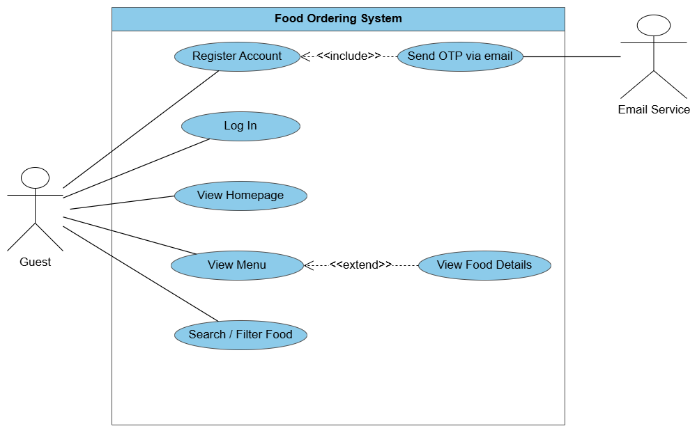

1.1.3.2 UCs for Customer
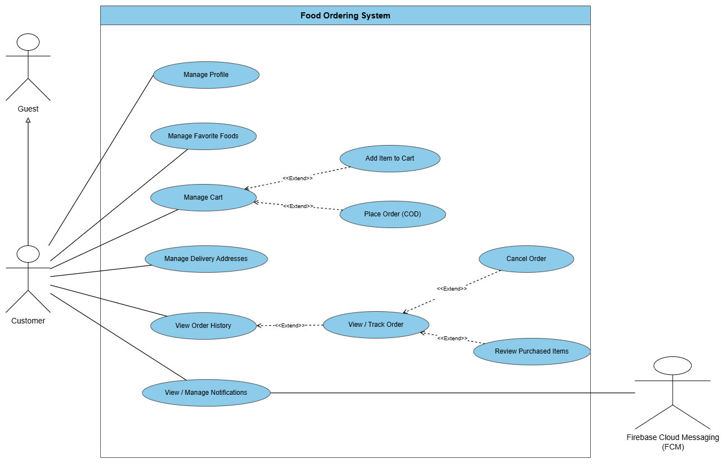

1.1.3.3 UCs for Admin
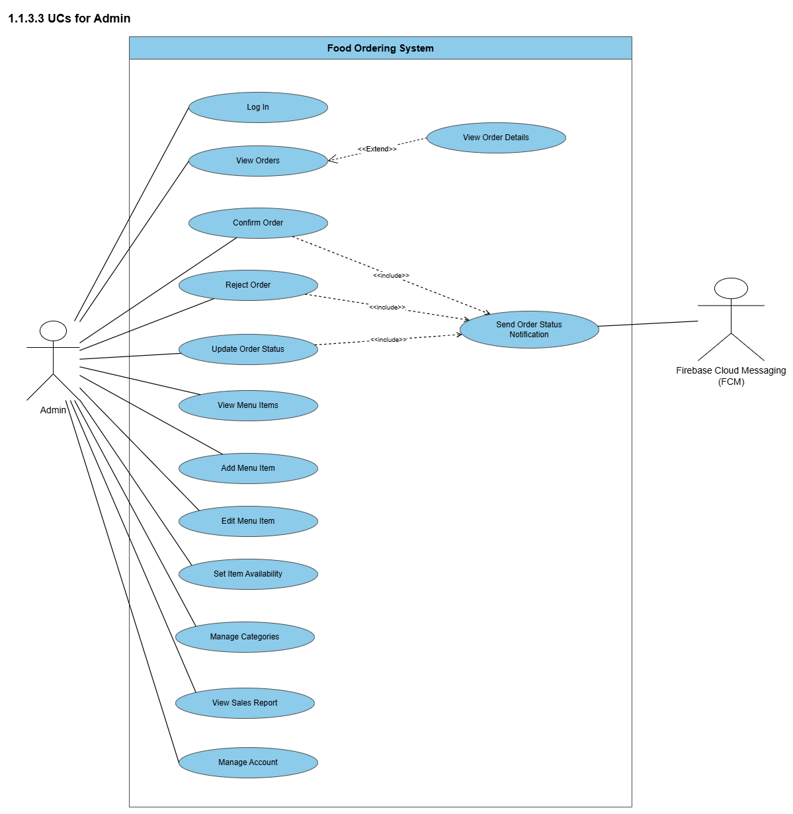

1.2 Entity Relationship Diagram
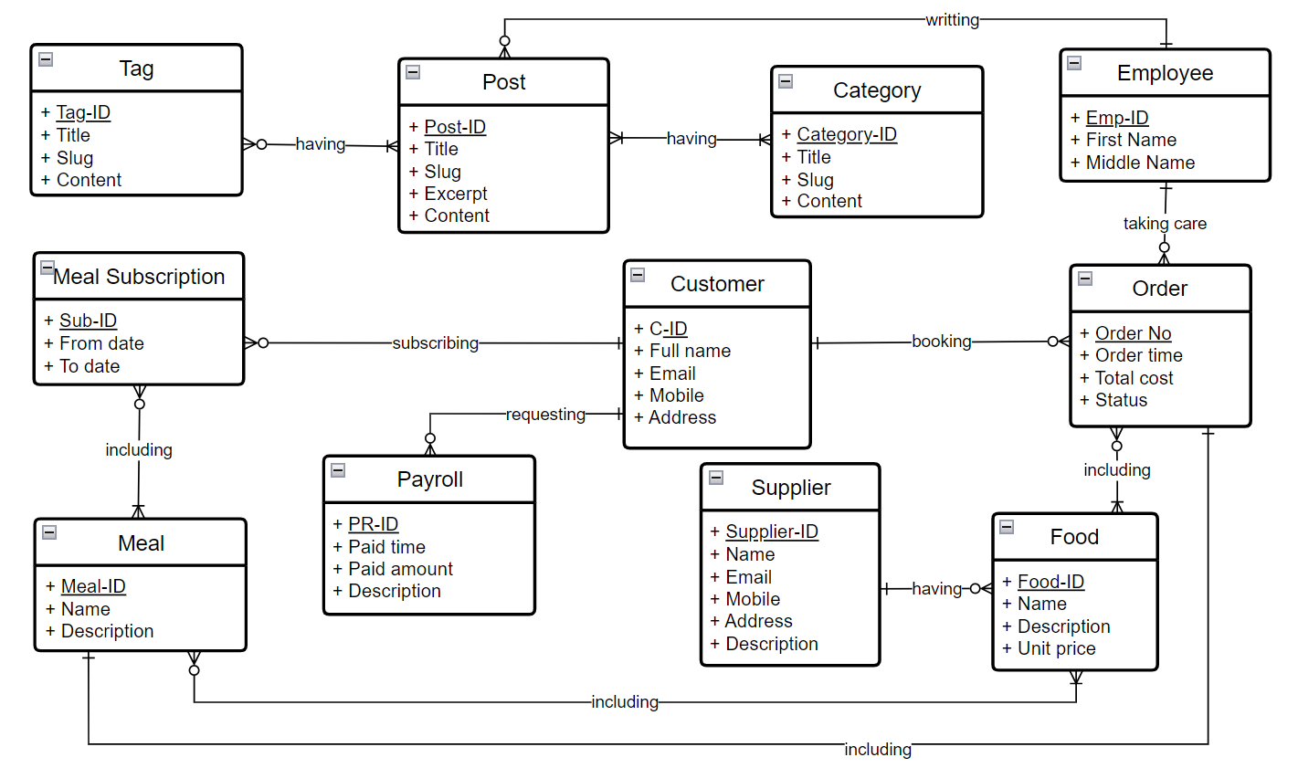
Entities Description
# | Entity | Description
1 | Patrol | Cafeteria’s customer information
2 | Meal | …
3 | …

2. Use Case Specifications

2.1 User Account Management

2.1.1 Register Account

UC ID and Name: | UC1- Register Account
Created By: | ThaiDQ | Date Created: | 16/10/2026
Primary Actor: | Guest | Secondary Actors: | Email Service (sends welcome / verification email)
Trigger: | Guest chooses to register a new account from the Welcome or Sign In screen.
Description: | As a Guest, I want to create an account with my full name, email, phone number, and password so that I can become a registered Customer and access personalized features such as ordering food, saving delivery addresses, and tracking orders.
Preconditions: | PRE-1: Guest has access to the application and has an internet connection.  PRE-2: Guest is currently unauthenticated (not logged into any account).
Postconditions: | POST-1 (Success): A new user record is created in Firebase Authentication and a corresponding user profile document is stored in Firestore with the default role "Customer".  POST-2: Guest transitions to Customer; the system establishes an authenticated session and redirects to the Home screen.  POST-3: Email Service delivers a welcome email to the registered email address.  POST-4 (Failure): No account is created, Guest remains unauthenticated, and the registration form retains valid inputs with error indicators on invalid fields.
Normal Flow: | Guest clicks the "Sign Up" button from the login/welcome screen.  The system displays the Registration screen with fields: Full Name, Email, Phone Number, Password, and Confirm Password.  Guest enters the required registration details.  Guest clicks the "Register" button.  The system validates the input format (non-empty fields, valid email syntax, valid phone format, password ≥\ge≥ 6 characters, and matching password confirmation).  The system checks that the email address is not already registered.  The system creates the authentication credentials in Firebase Auth.  The system creates a user profile document in Firestore with role set to "Customer".  The system triggers Email Service to send a welcome email.  The system initiates an authenticated session for the newly created Customer.  The system displays a welcome message and redirects to the Home screen.
Alternative Flows: | Step 1_1 – Switch to Login:  - Guest realizes they already have an account and clicks "Already have an account? Sign In".  - The system redirects Guest to the Login screen (UC02).
Exceptions: | E1 – Missing required fields: Guest leaves one or more fields empty. The system displays inline error messages: "This field is required."  E2 – Invalid email format: Guest inputs an invalid email string. The system highlights the email field and displays: "Please enter a valid email address."  E3 – Email already in use: The entered email is already registered. The system displays: "Email is already registered. Please sign in instead."  E4 – Weak password: Password is less than 6 characters. The system displays: "Password must be at least 6 characters."  E5 – Password mismatch: Confirm Password does not match Password. The system displays: "Passwords do not match."  E6 – Network/Firebase error: Unable to communicate with authentication services. The system retains entered data and prompts: "Network error. Please check your connection and try again."
Priority: | High
Frequency of Use: | Moderate – executed once per new user onboarding.
Business Rules: | BR-07 (Guests cannot assign or choose Admin role during self-registration).
Other Information: | All registered accounts default strictly to the "Customer" role; Admin accounts are pre-provisioned.
Assumptions: | Firebase Authentication and Firestore services are properly configured and operational.

2.1.2 Log In

UC ID and Name: | UC2-Login System
Created By: | ThaiDQ | Date Created: | 16/10/2026
Primary Actor: | Guest (or Registered Customer, Admin) | Secondary Actors: | Email Service (for password reset flows)
Trigger: | User chooses to log into the application or attempts to access a feature that requires authentication.
Description: | As an unauthenticated User (Customer or Admin), I want to log into the system using my registered email and password so that I can access features authorized for my specific role.
Preconditions: | PRE-1: User account has already been created (self-registered Customer or pre-provisioned Admin account) and is active.  PRE-2: User is currently unauthenticated and viewing the Login screen.
Postconditions: | POST-1 (Success): User credentials are authenticated, a valid session is created, and user role (Customer or Admin) is resolved from Firestore.  POST-2: Customer is routed to the Home screen (or previously requested feature/cart); Admin is routed to the Management Dashboard / Order Queue.  POST-3 (Failure): Authentication fails, session remains unauthenticated, and User stays on the Login screen with an error message.
Normal Flow: | User clicks the "Sign In" button from the header, welcome screen, or is prompted when accessing an authenticated feature.  The system displays the Login screen with Email and Password input fields.  User enters registered Email and Password.  User clicks the "Sign In" button.  The system validates that both fields are non-empty.  The system verifies credentials with Firebase Authentication.  The system retrieves the user profile and role (role: "Customer" or role: "Admin") from Firestore.  The system establishes the authenticated user session.  The system routes the User based on their role:  - If role is Customer: system directs to the Home screen (or the previous checkout/cart flow).  - If role is Admin: system directs to the Order Queue / Management Dashboard.
Alternative Flows: | Step 3_1 – Forgot Password:  - User clicks the "Forgot Password?" link.  - The system displays the Password Reset screen/modal.  - User enters registered email and clicks "Send Reset Link".  - The system validates the email and requests Email Service to dispatch a secure reset link.  - The system displays a confirmation message and returns to the Login screen.  Step 3_2 – Switch to Registration (For Guests only):  - User does not have an account and clicks "Don't have an account? Sign Up".  - The system redirects user to the Registration screen (UC01).
Exceptions: | E1 – Blank input fields: User leaves Email and/or Password blank. The system displays: "Please enter both email and password."  E2 – Incorrect credentials: Email does not exist or password is incorrect. The system displays: "Invalid email or password. Please try again."  E3 – Deactivated/Blocked account: The user account has been disabled. The system rejects login and displays: "Your account has been deactivated. Please contact support."  E4 – Too many failed attempts: User inputs incorrect credentials 5 times consecutively. The system temporarily locks authentication for 15 minutes and displays: "Too many failed login attempts. Please try again in 15 minutes."  E5 – Network connection error: Device cannot connect to authentication server. The system keeps inputs and displays: "Network error. Please check your internet connection and try again."
Priority: | High
Frequency of Use: | Very frequent – executed whenever a user opens the app without an active session or after session expiration.
Business Rules: | BR-07 (Role-based access control: user role strictly determines accessible modules upon login; Admin accounts cannot be self-registered).
Other Information: | Session tokens are persisted locally so users remain logged in across application restarts until explicit logout.
Assumptions: | Firebase Auth securely handles credential validation, encryption, and token management.

2.2 Cart Management

2.2.1 Add Item to Cart

UC ID and Name: | UC09 – Add Item to Cart
Created By: | LinhNTN | Date Created: | 16/10/2026
Primary Actor: | Customer | Secondary Actors: | None
Trigger: | Customer selects a food item and chooses to add it to the cart.
Description: | As a Customer, I want to add a selected food item with my preferred size, toppings, quantity, and note to the cart so that I can prepare the items before placing an order.
Preconditions: | PRE-1: Customer is logged into the system.  PRE-2: The selected food item exists and is currently available for sale.  PRE-3: Customer is viewing the food detail screen.
Postconditions: | POST-1 (Success): The selected item and its options are added to the Customer’s cart.  POST-2: The cart subtotal and total quantity are recalculated.  POST-3 (Failure): If validation fails, the cart remains unchanged.
Normal Flow: | - Customer opens the detail screen of a food item.  - The system displays the item information, price, available sizes and toppings.  - Customer selects the desired size.  - Customer selects optional toppings, if any.  - Customer specifies the quantity.  - Customer optionally enters a note for the item.  - Customer selects Add to Cart.  - The system validates the selected item and options.  - The system calculates the item price based on the selected size, toppings and quantity.  - The system adds the configured item to the cart.  - The system recalculates the cart subtotal and total quantity.  - The system displays a confirmation that the item has been added successfully.
Alternative Flows: | Step 3_1 – No Size Options Available  - The system skips size selection if the item has no size options.  - Continue from Step 4 of the Normal Flow.  Step 10_1 – Identical Item Already in Cart  - The system detects an identical item configuration in the cart.  - The system increases its quantity instead of adding a new entry.  - Continue from Step 11 of the Normal Flow.
Exceptions: | E1 – Item is unavailable: The item has been marked unavailable before the Customer adds it to the cart. The system shows an unavailable-item message and does not add the item.  E2 – Invalid quantity: Customer enters a quantity less than 1 or above the allowed limit. The system displays a validation message and asks the Customer to enter a valid quantity.  E3 – Required option is missing: If a required option such as size has not been selected, the system asks the Customer to complete the selection.  E4 – Network/database error: The system cannot update cart data because of a Firestore/network error. The current cart is kept unchanged and the Customer is asked to retry.
Priority: | High
Frequency of Use: | Very frequent – used whenever a Customer wants to purchase food.
Business Rules: | BR-01, BR-02, BR-03
Other Information: | The cart belongs to one Customer and one restaurant only.
Assumptions: | Menu data and item availability are synchronized with Firestore.

2.2.2 Update Cart Item

UC ID and Name: | UC10 – Update Cart Item
Created By: | LinhNTN | Date Created: | 16/10/2026
Primary Actor: | Customer | Secondary Actors: | None
Trigger: | Customer selects an existing item in the cart and chooses to modify it.
Description: | As a Customer, I want to update the quantity, size, toppings, or note of an item in my cart so that the cart reflects my current order preferences before checkout.
Preconditions: | PRE-1: Customer is logged into the system.  PRE-2: Customer’s cart contains at least one item.  PRE-3: The selected cart item still refers to a valid menu item.
Postconditions: | POST-1 (Success): The selected cart item is updated successfully.  POST-2: The item price, subtotal and cart total are recalculated.  POST-3: If quantity becomes zero through a remove action, the item is removed from the cart.  POST-4 (Failure): The previous cart data remains unchanged.
Normal Flow: | - Customer opens the Cart screen.  - The system displays all items currently stored in the cart, including selected options, quantity, item subtotal and cart total.  - Customer selects an item to modify.  - The system displays the item’s current configuration.  - Customer changes one or more values, such as size, toppings, quantity or note.  - Customer confirms the update.  - The system validates the new configuration.  - The system recalculates the price of the selected cart item.  - The system updates the cart item.  - The system recalculates the cart subtotal and total amount.  - The system displays the updated cart.
Alternative Flows: | Step 5_1 – Update Quantity Only  - Customer changes only the item quantity.  - The system validates the quantity, saves the change, and recalculates the cart total.  - Continue from Step 11 of the Normal Flow.  Step 2_1 – Remove Item  - Customer selects Remove and confirms.  - The system removes the item and recalculates the cart total.  - Continue from Step 11 of the Normal Flow.  Step 5_3 – Cancel Editing  - Customer cancels the modification.  - The system retains the original item information and returns to the Cart screen.
Exceptions: | E1 – Item becomes unavailable: The selected food item is no longer available. The system informs the Customer and prevents further ordering of that item.  E2 – Selected option becomes unavailable: A previously selected size or topping is no longer offered. The system asks the Customer to choose another valid option.  E3 – Invalid quantity: The quantity entered is outside the accepted range. The system displays a validation message and does not save the change.  E4 – Network/database error: The cart cannot be updated due to a network or Firestore failure. The previous cart state is retained and the system asks the Customer to retry.
Priority: | High
Frequency of Use: | Frequent – may occur several times before checkout.
Business Rules: | BR-01, BR-02, BR-03
Other Information: | Changes in the cart do not create an order until the Customer confirms checkout.
Assumptions: | The system has access to the latest item price and availability information.

2.3 Order Management

2.3.1 Place Order (COD)

UC ID and Name: | UC-ORD-01: Place Order (COD)
Created By: | Ngo Hong Anh | Date Created: | 16/10/2026
Primary Actor: | Customer | Secondary Actors: | Firebase Cloud Messaging (FCM)
Trigger: | The customer clicks the "Place Order" button in the Cart screen or Checkout screen.
Description: | Extending from Manage Cart, this use case allows a customer to submit an order containing the items in their cart and select Cash on Delivery (COD) as the payment method.
Preconditions: | The customer is logged into their account.  The shopping cart contains at least one active food item.  A valid delivery address and phone number are provided.
Postconditions: | A new order record is created with the status set to "Pending".  The ordered items are removed from the customer's cart.  A confirmation notification is dispatched via FCM to the customer, and an alert is sent to the admin.
Normal Flow: | - Customer opens the Cart screen.  - Customer selects "Place Order".  - The system displays the Checkout screen with cart items, quantities, prices, and the selected delivery address.  - The system calculates the delivery fee based on the distance between the restaurant and the delivery address.  - The system displays the delivery fee and total order amount.  - Customer reviews the order details and confirms the order using COD.  - The system validates the delivery address and food availability.  - The system creates an order with status "Pending".  - The system clears the ordered items from the cart.  - The system notifies Admin of the new order and displays the order confirmation to Customer.
Alternative Flows: | Step 6_1 – Change Delivery Address  - Customer selects or adds another delivery address.  - The system recalculates the delivery fee based on the new distance.  - The system updates the total order amount.  - Return to Step 6 of the Normal Flow.  Step 6_2 – Add Special Delivery Instructions  - Customer enters optional delivery instructions.  - The system retains the instructions for the order.  - Return to Step 6 of the Normal Flow.
Exceptions: | E1: Food item unavailable or sold out:  At step 5, if one or more items are out of stock or marked unavailable, the system notifies the customer, cancels submission, and prompts them to update their cart.  E2: Order amount exceeds maximum COD threshold:  At step 5, if the total order value exceeds the system's maximum allowed limit for cash payments, the system notifies the user and asks to adjust item quantities or change payment methods.  E3 – Delivery Address Outside Service Area  If the delivery distance exceeds 8 km, the system prevents order confirmation and asks the Customer to select another delivery address.  E4 – Unable to Calculate Delivery Distance  If the system cannot determine the delivery distance, it displays an error message and prevents order confirmation until a valid distance is obtained.
Priority: | High
Frequency of Use: | Very Frequent (every time a customer submits a purchase).
Business Rules: | Delivery fees are calculated based on the distance between the restaurant and the selected delivery address.  A delivry fee of 15,000 VND applies to distances up to 3 km.  A delivery fee of 20,000 VND applies to distances greater than 3 km and up to 5 km.  A delivery fee of 30,000 VND applies to distances greater than 5 km and up to 8 km.  Orders with delivery distances greater than 8 km are not accepted.  The system must recalculate the delivery fee whenever the delivery address changes.  The order total equals the sum of item subtotals plus the delivery fee.
Other Information: | Order ID must follow a structured format (e.g., ORD-YYYYMMDD-XXXX).
Assumptions: | Firebase Cloud Messaging (FCM) is online and operating without latency.

2.3.2 Cancel Order

UC ID and Name: | UC-ORD-02: Cancel Order
Created By: | Ngo Hong Anh | Date Created: | 16/10/2026
Primary Actor: | Customer | Secondary Actors: | Firebase Cloud Messaging (FCM)
Trigger: | The customer clicks the "Cancel Order" button on the order tracking screen (View / Track Order)
Description: | Extends from View / Track Order, this use case allows a customer to cancel an active order as long as it remains in the "Pending" status awaiting restaurant confirmation.
Preconditions: | Customer is logged in.  The selected order currently possesses a "Pending" status.
Postconditions: | The order status updates to "Cancelled".  A cancellation notification is routed to the admin.
Normal Flow: | Customer navigates to order history and selects the relevant order (View / Track Order).  Customer clicks "Cancel Order".  System displays a confirmation dialog asking for the cancellation reason.  Customer selects or inputs the reason and confirms the cancellation request.  System checks the current order status on the backend server.  System changes the order status to "Cancelled" and records the timestamp and reason.  System dispatches a cancellation alert to the admin through FCM.  System updates the screen to reflect the cancelled status and displays a confirmation message.
Alternative Flows: | A1: Customer aborts cancellation:  At step 4, customer chooses "Dismiss" or "Keep Order".  System closes the dialog and keeps the order status unchanged.
Exceptions: | E1: Order already accepted by admin:  At step 5, if the admin has already updated the order status to "Confirmed" or "Preparing", the system halts cancellation, displays an error message stating the restaurant has already begun processing the order, and disables the cancel action.
Priority: | Medium
Frequency of Use: | Low to Moderate.
Business Rules: | Order cancellation by the customer is strictly restricted to the "Pending" status window.  Providing a cancellation reason is mandatory.
Other Information: | No refund flow is required since this applies to Cash on Delivery (COD) orders.
Assumptions: | Real-time state synchronization prevents race conditions between customer cancellation and admin confirmation.

2.3.3 Confirm Order

UC ID and Name: | UC-ORD-03: Confirm Order
Created By: | Ngo Hong Anh | Date Created: | 16/10/2026
Primary Actor: | Admin | Secondary Actors: | Firebase Cloud Messaging (FCM)
Trigger: | The admin clicks the "Confirm Order" button on the order list or order details screen.
Description: | Includes Send Order Status Notification, allowing the admin to acknowledge and accept a customer's pending order for preparation and notify the customer immediately.
Preconditions: | Admin is authenticated and logged into the administration panel.  The target order is in "Pending" status.
Postconditions: | Order status transitions to "Confirmed".  Push notification is delivered to the customer's device via FCM
Normal Flow: | Admin opens the pending order list (View Orders) and inspects the details (View Order Details).  Admin verifies kitchen availability and delivery feasibilities.  Admin clicks "Confirm Order".  System displays a confirmation prompt.  Admin confirms the action.  System updates the order status from "Pending" to "Confirmed".  System executes the included use case Send Order Status Notification, utilizing FCM to notify the customer that the order has been accepted.  System updates the order list view and indicates successful confirmation to the admin.
Alternative Flows: | None.
Exceptions: | E1: Order was cancelled by customer:  - At step 6, if the customer cancelled the order before confirmation, the system halts the update, displays a alert that the order has already been cancelled, and refreshes the data.
Priority: | High
Frequency of Use: | Very Frequent (executed for every accepted order during operating hours).
Business Rules: | Only users with administrative or order-management roles may confirm orders.  Orders should be confirmed within the restaurant's target Service Level Agreement (SLA) (e.g., 5–10 minutes).
Other Information: | System logs the administrator's ID and timestamp for audit purposes.
Assumptions: | FCM service is reachable to relay real-time order status updates to the customer.

2.3.4 Reject Order

UC ID and Name: | UC-ORD-04: Reject Order
Created By: | Ngo Hong Anh | Date Created: | 16/10/2026
Primary Actor: | Admin | Secondary Actors: | Firebase Cloud Messaging (FCM)
Trigger: | The admin clicks the "Reject Order" button for a pending order.
Description: | Includes Send Order Status Notification, allowing the admin to decline an incoming order due to operational constraints (out of stock, kitchen capacity reached, invalid delivery area) and inform the customer with a documented reason.
Preconditions: | Admin is authenticated and logged in.  The order is currently in "Pending" status.
Postconditions: | Order status changes to "Rejected".  The customer receives an FCM notification explaining the decline reason.
Normal Flow: | Admin views the pending order and determines it cannot be fulfilled.  Admin clicks "Reject Order".  System presents a modal dialog requesting a rejection reason (e.g., "Out of Stock", "Kitchen Overloaded", "Outside Delivery Range", or custom input).  Admin selects or types a reason and confirms rejection.  System updates the order record status to "Rejected" and saves the rejection reason.  System invokes Send Order Status Notification via FCM to send the decline explanation to the customer.  System displays a success banner to the admin and removes the item from the pending list.
Alternative Flows: | A1: Admin cancels rejection:  At step 4, admin cancels the dialog.  System retains the original order status.
Exceptions: | E1: Missing rejection reason:  At step 4, if the admin submits without selecting or typing a reason, the system prompts an error requiring a reason before proceeding.
Priority: | High
Frequency of Use: | Occasional (during rush hours, kitchen emergencies, or stock runouts).
Business Rules: | A clear rejection reason is mandatory to ensure transparency for the customer.  Rejected orders are permanently closed and cannot be reopened.
Other Information: | Rejection statistics are tracked for operational performance reviews.
Assumptions: | FCM service handles payload delivery reliably.

2.3.5 Update Order Status

UC ID and Name: | UC-ORD-05: Update Order Status
Created By: | Ngo Hong Anh | Date Created: | 16/10/2026
Primary Actor: | Admin | Secondary Actors: | Firebase Cloud Messaging (FCM)
Trigger: | The admin advances the progress state of an active order.
Description: | Includes Send Order Status Notification, enabling the admin to progress an order through its standard fulfillment lifecycle stages ("Preparing" -> "Out for Delivery" -> "Completed") and keep the customer informed at each stage.
Preconditions: | Admin is logged in.  The order has already been confirmed and is in an active processing status.
Postconditions: | The order status is updated to the selected stage.  Real-time push notifications are sent to the customer via FCM.  Completing the order activates the review functionality for the customer.
Normal Flow: | Admin opens the active order details screen (View Order Details).  Admin selects the appropriate subsequent lifecycle state:  "Preparing" (Food is being cooked).  "Out for Delivery" (Dispatched to courier).  "Completed" (Delivered successfully).  Admin clicks "Update Status".  System validates the state transition sequence.  System updates the status in the database and logs the timestamp.  System calls the included use case Send Order Status Notification, dispatching an FCM push notification to the customer.  System displays a confirmation alert to the admin and updates the interface.
Alternative Flows: | None.
Exceptions: | E1: Non-sequential state transition:  At step 4, if the admin attempts an invalid transition (e.g., jumping from "Confirmed" directly to "Completed" without delivery), the system requests confirmation or restricts the action based on workflow rules.
Priority: | High
Frequency of Use: | Continuous (executed multiple times across the lifecycle of every active order).
Business Rules: | Normal sequential progression: Pending -> Confirmed -> Preparing -> Out for Delivery -> Completed.  Reaching "Completed" status logs the sale into the sales report (View Sales Report) and enables the customer to submit food ratings (Review Purchased Items).
Other Information: | Driver/shipper contact info can optionally be included when transitioning to "Out for Delivery".
Assumptions: | Network connections between the administrative client, application server, and FCM gateway remain stable.

2.4 Review Management

2.4.1 Review Purchased Items

UC ID and Name: | UC-Review-01: Review Purchased Items
Created By: | TienPQ | Date Created: | 26/10/2026
Primary Actor: | Customer | Secondary Actors: | None
Trigger: | Customer navigates to a Completed Order Details screen and selects "Write Review" / "Rate Product" next to an unreviewed item.
Description: | Allows a customer to submit a rating score (1–5 stars), written comment, and optional photo attachments for a food item purchased in a completed order. ed on the product detail page and update the item's average rating.
Preconditions: | 1. Customer is logged in system.  2. The order containing the item has status Completed.  3.The item has not been reviewed (IsReviewed = False).  4.Order completion date is within 30 days.
Postconditions: | 1.Review record created in DB (Rating, Comment, MediaURLs, IsAnonymous, CreatedAt).  2.Item status updated to IsReviewed = True.  3.Product average rating score and total rating count recalculated.  4.Review published on the Product Details page.
Normal Flow: | 1.Customer accesses Completed Order Details screen .  2.Customer taps "Write Review" button next to an eligible unreviewed item line.  3.System opens Submit Review Screen displaying the item's summary (image, name, variants).  4.Customer selects a star rating score from 1 to 5 stars.  5.Customer enters written feedback into the text area.  6.Customer uploads optional photo attachments (up to 3 images).  7.Customer selects whether to post anonymously (IsAnonymous).  8.Customer clicks "Submit Review".  9.System validates input data against business rules 10.System saves review record to DB, marks item as IsReviewed = True, recalculates product average score, and displays success notification.  11.System redirects Customer back to Order Details screen with button updated to "View Review".
Alternative Flows: | 1.Customer views a Product Details page for a previously purchased item.  2.System detects an unreviewed completed purchase for this item and displays a banner: "You purchased this item. Rate it now!".  3.Customer taps the banner.  4.Return to Step 3 of Normal Flow.
Exceptions: | E1 – Invalid Input / Validation Error:  - At Step 9, if star rating is missing, or comment $<10$ characters for 1–2 star ratings, system displays inline error message and keeps form data intact.  E2 – Upload Failure / File Exceeds Limit:  - At Step 6, if an image exceeds 5MB or upload fails, system cancels file attachment and displays: "Image upload failed. File size must be under 5MB."  E3 – Review Window Expired:  - At Step 2, if order completion date exceeds 30 days, system disables review action and displays: "The review window for this item has closed."
Priority: | High
Frequency of Use: | High – triggered after orders are completed.
Business Rules: | Only accounts with a Completed order containing the specific SKU can submit a review.  Star rating (1–5) is mandatory. Text is optional for 3–5 stars, but mandatory ($≥10$ chars) for 1–2 stars.  Text maximum length is 500 characters. Attachments capped at 3 images ($≤5MB$ each).
Other Information: | Anonymous reviews mask full customer names on public views .
Assumptions: | Cloud Object Storage is operational for image uploads.

2.4.2 View Personal Review Details

UC ID and Name: | UC-Review-02: View Personal Review Details
Created By: | TienPQ | Date Created: | 26/10/2026
Primary Actor: | Customer | Secondary Actors: | None
Trigger: | Customer selects "View Review" next to a previously reviewed item in their Order Details or Order History screen.
Description: | Allows a customer to view their submitted star rating, written feedback, photo gallery, and official merchant reply for a purchased food item.
Preconditions: | 1.Customer is logged into the system.  2.The item has already been reviewed (IsReviewed = True).
Postconditions: | 1.System displays full review details and current action capabilities (Edit/Delete eligibility).
Normal Flow: | 1.Customer accesses Completed Order Details screen .  2.Customer taps "View Review" button next to a reviewed item line.  3.System retrieves review details from DB based on ReviewID.  4.System opens View Review Detail Screen.  5.System displays submitted star rating, text comment, attached media gallery, and submission timestamp.  6.System checks merchant response table and displays store owner reply (if available).  7.System checks action windows and enables/disables "Edit Review" and "Delete Review" buttons accordingly.
Alternative Flows: | None.
Exceptions: | E1 – Review Record Not Found:  - At Step 3, if review record was deleted or corrupted, system displays error message "Review not found" and redirects to Order Details screen.
Priority: | Medium
Frequency of Use: | Medium – triggered when customers want to check past feedback or merchant responses.
Business Rules: | "Edit Review" button is displayed only if current time is within 7 days of submission AND review has not been edited yet (IsEdited = False).  "Delete Review" button is displayed only if current time is within 30 days of initial submission.
Other Information: | Clicking any thumbnail image expands it into a full-screen image preview lightbox.
Assumptions: | Merchant responses are linked directly via ReviewID.

2.4.3 EDIT AND DELETE REVIEW

UC ID and Name: | UC-Review-03: Edit and Delete Review
Created By: | TienPQ | Date Created: | 26/10/2026
Primary Actor: | Customer | Secondary Actors: | None
Trigger: | Customer selects "Edit Review" or "Delete Review" on the View Review Detail Screen.
Description: | Allows a customer to update their previously submitted rating, comment, and photos (within 7 days), or permanently remove their review (within 30 days).
Preconditions: | 1.Customer is logged into the system and is the owner of the review.  2.Review record exists in DB.  3.For Edit: CreatedAt <= 7 days AND IsEdited = False.  4.For Delete: CreatedAt <= 30 days.
Postconditions: | 1.On Edit Success: Review record updated in DB, IsEdited = True, product average rating score recalculated.  2.On Delete Success: Review record removed/soft-deleted in DB, item status reset to IsReviewed = False, product average rating score recalculated.
Normal Flow: | 1.Customer navigates to View Review Screen and taps "Edit Review".  2.System opens Edit Review Screen pre-populated with existing rating, text comment, and attached media URLs.  3.Customer modifies rating stars, edits written text, or updates attached photos (add/remove).  4.Customer clicks "Update Review".  5.System validates updated inputs against business rules .  6.System updates review record in DB, marks IsEdited = True, recalculates product average rating, and returns Customer to View Review Screen with success notification.
Alternative Flows: | 1.Customer navigates to View Review Screen and taps "Delete Review".  2.System displays confirmation modal : "Are you sure you want to delete this review? This action cannot be undone."  3.Customer clicks "Confirm Delete".  4.System removes/soft-deletes review record from DB.  5.System resets order item status to IsReviewed = False.  6.System recalculates product average rating score and total review count.  7.System redirects Customer back to Completed Order Details screen (SCR-ORD-01) with button updated to "Write Review".
Exceptions: | E1 – Edit Window Expired:  - At Step 1 (Edit Branch), if CreatedAt > 7 days or IsEdited = True, system blocks request and displays: "This review can no longer be edited."  E2 – Delete Window Expired:  - At Step 1 (Delete Branch), if CreatedAt > 30 days, system blocks request and displays: "The deletion period for this review has expired."  E3 – Update Validation Error:  - At Step 5, if comment $<10$ characters for 1–2 star ratings or file size $>5MB$, system halts submission and displays inline error.
Priority: | Medium
Frequency of Use: | Low – triggered only when customers need to modify or withdraw feedback.
Business Rules: | A review can be edited at most once within a 7-day window post-submission.  A review can be deleted within 30 days of initial submission.  Both Edit and Delete actions must immediately trigger a recalculation of the product's overall rating score ($\bar{R}$) and total rating count.
Other Information: | Deleting a review restores the customer's eligibility to submit a new review for that item if still within 30 days of order completion.
Assumptions: | Background recalculation job executes instantly upon DB record update/deletion.

2.5 Notification Management

2.5.1 Send Order Status Notification

UC ID and Name: | UC - Send Order Status Notification
Created By: | Viet | Date Created: | 16/10/2026
Primary Actor: | System | Secondary Actors: | Admin, Firebase Cloud Messaging (FCM), Customer
Trigger: | The status of an order is updated by Admin (e.g., Confirmed, Preparing, Out for Delivery, Completed, Rejected) or automatically updated by the system.
Description: | As a customer, I want to receive real-time push notifications regarding my order status updates so that I can stay informed about the preparation and delivery progress of my meal.
Preconditions: | PRE-1: Customer account is created and logged in on a mobile device with FCM push notification permissions enabled.  PRE-2: The order exists in the system and undergoes a valid status transition.
Postconditions: | POST-1 (Success): System sends a real-time push notification to the customer's device successfully.  POST-2: System saves the notification record into the Customer's Notification History in Firestore.
Normal Flow: | Send Order Status Notification  1. Admin or System updates the status of an order (e.g., Confirmed, Preparing, Out for Delivery, Completed, Rejected).  2. System generates a notification payload containing Order ID, title, status message, timestamp, and deep-link reference.  3. System triggers Notification Service via Firebase Cloud Messaging (FCM) using the customer's registered device token.  4. FCM delivers the push notification to the customer's mobile device.  5. System creates and stores a notification document in the customer's notification collection in Firestore.  6. Customer taps the notification banner.  7. System opens the app and directs user to the Order Details screen for the corresponding order.
Alternative Flows: | Step 4.1_FCM delivery failed or device offline  1. At step 4, if customer's device is offline, FCM queues the notification for a predefined Time-To-Live (TTL) period and delivers it once connection is restored.  2. If device token is invalid or expired, system logs delivery failure and invalidates the stale token.  Step 6.1_Customer taps notification when app is closed / in background  1. At step 6, customer taps the push notification while the app is closed or running in background.  2. System launches the app, verifies user session, and retrieves the Order ID from the notification payload.  3. Return to step 7 of normal flow.
Exceptions: | E1 – Invalid or Expired Token: Customer's device token is no longer valid. The system catches the error, cancels push delivery, and logs the issue.  E2 – Network/Database Error: System cannot store the notification document in Firestore due to network failure. The push notification is still dispatched, but the in-app inbox entry creation is retried.
Priority: | High
Frequency of Use: | Frequent – triggered multiple times during the lifecycle of every active order.
Business Rules: | BR-01: Every order status transition must automatically generate a corresponding notification record.  BR-02: Tapping an order status notification must navigate the Customer directly to the specific Order Details screen.
Other Information: | Notifications rely on Firebase Cloud Messaging (FCM) infrastructure and Firestore real-time synchronization.
Assumptions: | FCM push notification service is online and operating without latency.

2.5.2 Notify Admin of New or Canceled Orders

UC ID and Name: | UC - Notify Admin of New or Canceled Orders
Created By: | Viet | Date Created: | 16/10/2026
Primary Actor: | Customer | Secondary Actors: | System, Firebase Cloud Messaging (FCM), Admin
Trigger: | Customer submits a new order or cancels an existing pending order.
Description: | As an Admin, I want to receive immediate alerts when a new order is placed or when a pending order is canceled by a customer so that I can process orders promptly or adjust kitchen operations.
Preconditions: | PRE-1: Admin account is logged into the management panel/device.  PRE-2: Customer successfully places a new order or cancels a "Pending" order.
Postconditions: | POST-1 (Success): System delivers an instant push alert and audio/visual banner to the Admin's device.  POST-2: The Admin order queue/list is updated in real time with the new or canceled order state.
Normal Flow: | Notify Admin of New or Canceled Orders  1. Customer places a new COD order or cancels a "Pending" order.  2. System creates or updates the order document in Firestore.  3. System constructs an alert payload specifying the event type (New Order or Order Canceled), Order ID, and summary details.  4. System dispatches a push notification via FCM to all active Admin device tokens.  5. Admin device receives the instant push notification alert.  6. System automatically updates the Admin order queue UI in real time via Firestore listener.  7. Admin clicks the alert and system directs Admin to the Order Queue / Order Details screen.
Alternative Flows: | Step 4.1_Admin Device Offline  1. At step 4, push notification delivery fails or is delayed because the Admin device is offline.  2. Upon reconnecting, the real-time sync automatically updates the order queue to display the current order state.  Step 6.1_Admin Panel Open in Foreground (Real-time Sync)  1. At step 6, Admin is actively viewing the Order Queue screen.  2. System detects database change via real-time stream (Firestore listener).  3. System updates the order list dynamically on screen accompanied by an in-app audio chime/toast alert without requiring Admin to click a notification.
Exceptions: | E1 – FCM Service Disconnected: Push alert dispatch fails due to FCM network issue. The system falls back to Firestore real-time listeners to update the Admin UI upon reconnection.  E2 – Missing Admin Device Token: No active Admin devices are registered. The alert is logged in Firestore for display when an Admin logs in.
Priority: | High
Frequency of Use: | Very Frequent – triggered on every order creation or cancellation.
Other Information: | Supports broadcasting notifications to multiple active Admin/Staff devices simultaneously.
Assumptions: | Supports broadcasting notifications to multiple active Admin/Staff devices simultaneously.

Primary and Secondary Actors
An actor is a person or other entity external to the software system being specified who interacts with the system and performs use cases to accomplish tasks. Name the primary actor that will be initiating this UC and any other secondary actors who will participate in completing execution of the UC.
Description
Provide a brief description of the reason for and outcome of this use case, or a high-level description of the sequence of actions and the outcome of executing the use case. The description can be in the form of a user story (As a <type of user>, I want <some goal> so that <some reasons>)
Preconditions
List any activities that must take place, or any conditions that must be true, before the use case can be started.
Postconditions
Describe the state of the system at the successful conclusion of the use case execution.
Normal Flow
Provide a description of the user actions and corresponding system responses that will take place during execution of the use case under normal, expected conditions.
Alternative Flows
Describe below two information if any:
- Other successful usage scenarios that can take place within this use case. State the alternative flow, and describe any differences in the sequence of steps that take place.
- Any anticipated error conditions that could occur during execution of the use case and how the system is to respond to those conditions.

2.1.2 Login System
Primary Actors | Customer | Secondary Actors | None
Description | As a user, I want to be able to log into the system so that I can use the system’s authenticated features and access my personalized account.
Preconditions | User account has been created & authorized
Postconditions | - User logs in the system successfully  - The system tracked successful login into the Activity Log
Normal Sequence/Flow | Login System  - User clicks Login button from the page header or accesses an authenticated feature (from a link or type the page URL directly into the address bar)  - System show the User Login screen  - User types in the login details (email, password)  - User clicks the Login button  - System validates the login details (BR-01, BR-02)  - System allows user to access  - System tracks user’s success login to the Activity Log  - System directs user to the Home Page (or the previous calling page if any)
Alternative Sequences/Flows | Step 2.1_Google Login  - User clicks Google Login button to login system using Google account  - System redirects the user to the Google’s Login screen  - User types in the Google account details and chooses to login  - Google validates user’s login information successfully and redirect him/her back to the system  - Return to step 5 of normal flow.  Step 4_System can’t authenticate the user  User can’t be authenticated & get relevant error message in one of below cases  - He/she leaves the Email and/or Password field blank (MSG10)  - Input Email or Password are incorrect (MSG09)  - Input Email/Password are correct but email has not been verified (MSG11)  - The user account is blocked / inactive (MSG12)  If user inputs wrong logging-in details 5 times continuously, system will lock his/her account in 30 minutes (with relevant warning message - MSG13)

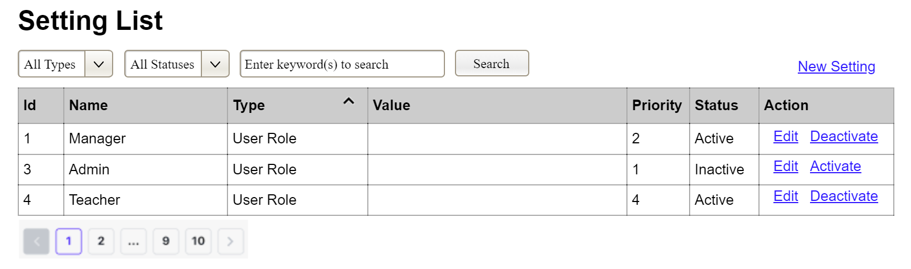
(3)
(2)
(1)
This screen allows the Administrator to:
- View Setting List: view list of current master data.
- Filter Setting List: filter master data by data types, statuses
- Search Settings: enter keyword(s) to search master data by their names or values
- Sort Setting List: sort master data list (ascending, descending) by clicking column headers
On the screen, s/he can also
- Activate/Deactivate Setting: change status of a specific inactive/active master data
- Choose to go to the Setting Details screens for adding new or updating an existing master data by clicking the New Setting or Edit link.
Field Description
Field Name | Description
(1) | Initial values: all the active setting names with null or blank type  Hover the mouse to show the field name: “Setting Type”
(2) | Initial values: All Statuses, Active, Inactive (default value “All Status”)  Hover the mouse to show the field name: “Setting Status”
(3) | The change-status action is Activate or Deactivate depending on the current status of the relevant setting (Inactive or Active, respectively).

2.1.3 UC Name2
…

2.2 Xyz Feature
…

3. Business Rules
[Provide common business rules that you must follow. The information can be provided in the table format as the sample below]
ID | Rule Definition
BR-01 | A Customer must be authenticated before adding or modifying items in the cart.
BR-02 | Each cart item must contain a valid food item, quantity, selected size if required, selected toppings if applicable, and an optional note.
BR-03 | Cart item subtotal must be recalculated whenever quantity, size, or toppings are changed.
BR-04 | All meals in a single order must be paid for by using the same payment method.
BR-11 | If an order is to be delivered, the patron must pay by payroll deduction.
BR-12 | Order price is calculated as the sum of each food item price times the quantity of that food item ordered, plus applicable sales tax, plus a delivery charge if a meal is delivered outside the free delivery zone.
BR-24 | Only cafeteria employees who are designated as Menu Managers by the Cafeteria Manager can create, modify, or delete cafeteria menus.
BR-33 | Network transmissions that involve financial information or personally identifiable information require 256-bit encryption.
BR-86 | Only regular employees can register for payroll deduction for any company purchase.
BR-88 | An employee can register for payroll deduction payment of cafeteria meals if no more than 40 percent of his gross pay is currently being deducted for other reasons.

